INF2003: Database Systems
Lab 02: SQL Basics in MariaDB

- Please download the installation package of MariaDB. Please visit the official webpage for downloading and instructions. After the successful installation, open the MySQL Client and get into MariaDB. Your first task in MariaDB is to create a local user using your name and grant privileges to the user. The 1st screenshot in your lab report includes a list of the users as well as the corresponding host in MariaDB. You will not get lab marks if your name as a local user is not shown in the screenshot. A sample screenshot is as follows.

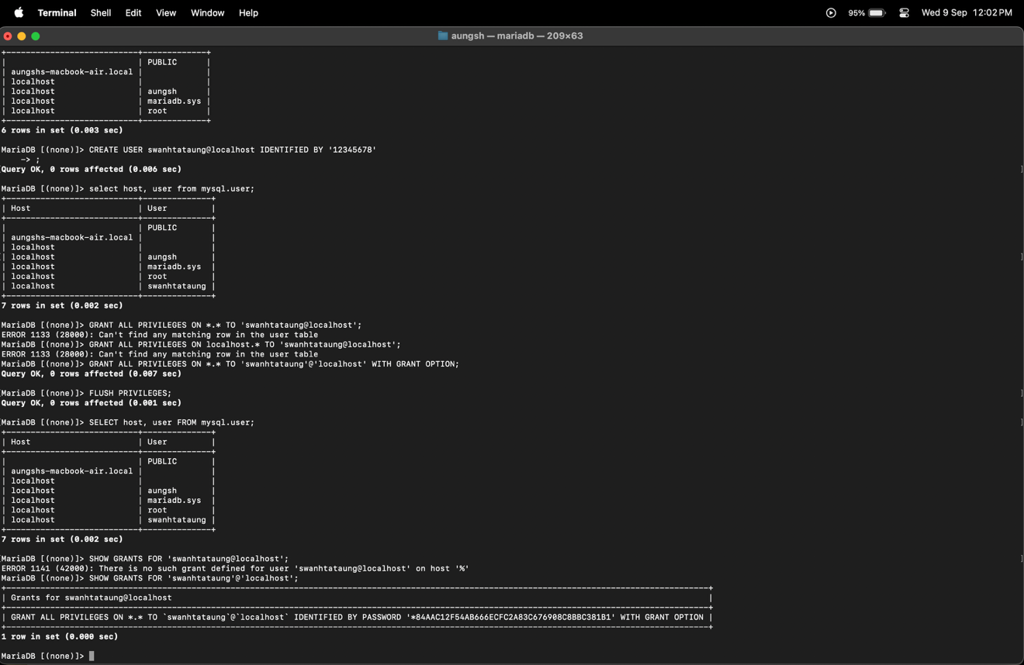
(Note: Please think about why we need to grant privileges. You are welcome to perform tests without granting privileges.)

CREATE USER swanhtataung@localhost IDENTIFIED BY '12345678';
GRANT ALL PRIVILEGES ON *.* TO 'swanhtataung'@'localhost' WITH GRANT OPTION;
FLUSH PRIVILEGES;
SELECT host, user FROM mysql.user;

- Using your newly created local user, create a database using your name, e.g., zhangweiDB. Then, create a table called students in the database. The table has 3 columns, namely sid (for student identifier as an integer and primary key), name (for the name of a student), and grade (for the grade of a student). The 2nd screenshot in your report includes a list of the databases in MariaDB. Here is a sample.

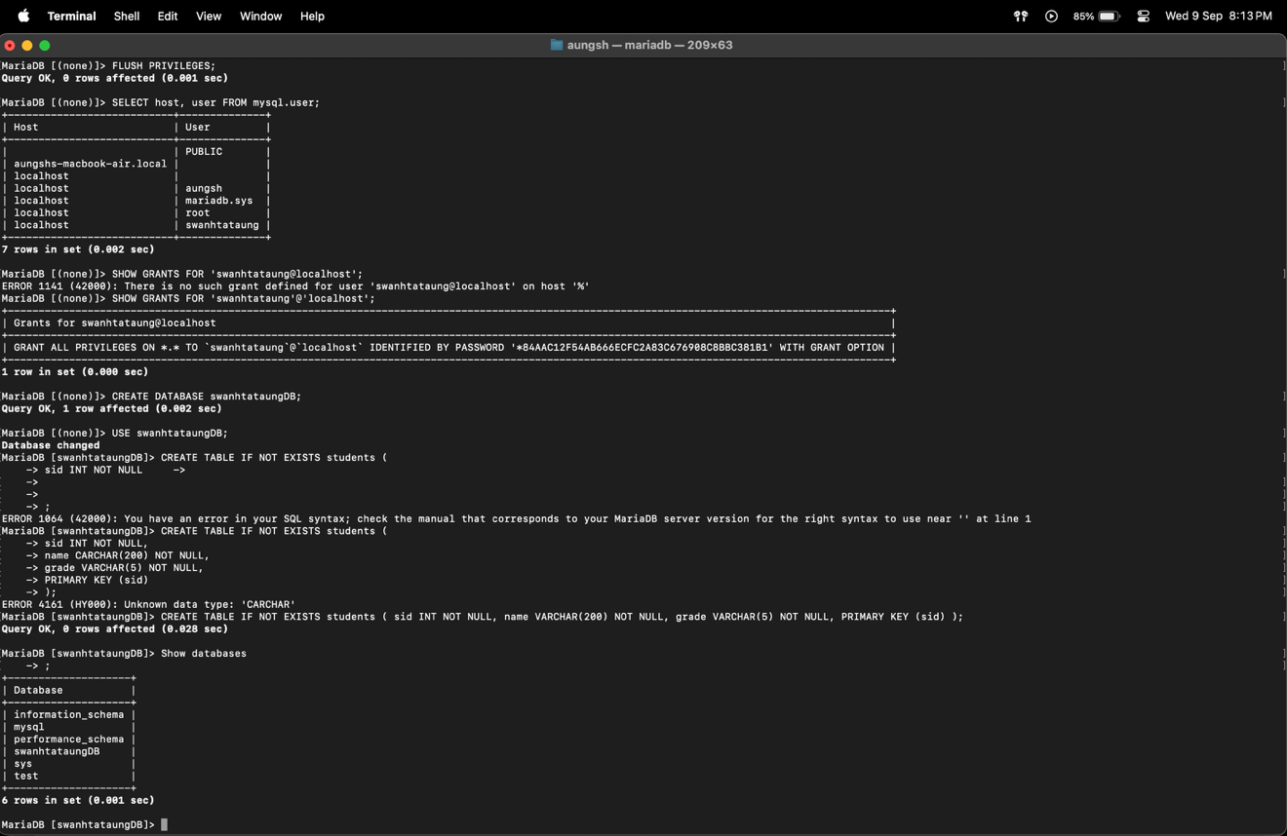

CREATE DATABASE swanhtataungDB;
USE swanhtataungDB;
CREATE TABLE IF NOT EXISTS students ( sid INT NOT NULL, name VARCHAR(200) NOT NULL, grade VARCHAR(5) NULL, PRIMARY KEY (sid) );
Show databases;

- Perform the 1st read operation in the table just created. Display all the rows, if any, in the table and check if the table is empty.
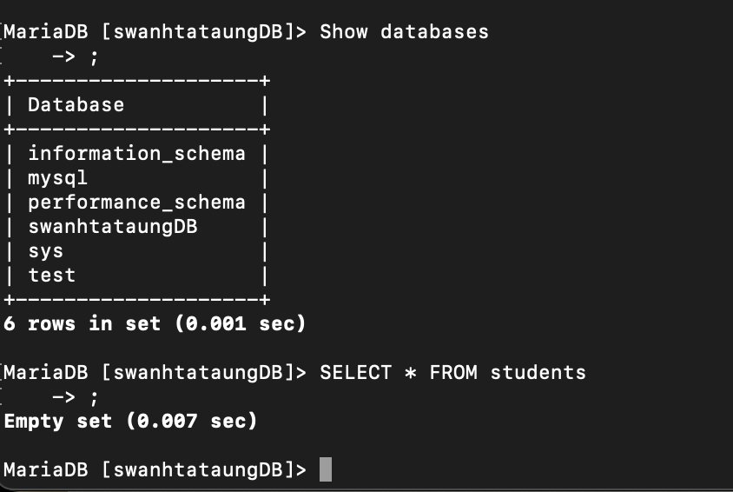

SELECT * FROM students;

- Perform the 1st insert operation by adding a new student (with sid 2001111, name ‘Lewis’, and with grade ‘NA’) into the table. Display all the rows in the latest table. Perform the 2nd and 3rd insert operations by adding a new student (with sid 2002222, name ‘Valtteri’, but without grade) and another new student (with sid 2003333, name ‘Michael’, but without grade) into the table. Display all the rows in the latest table.

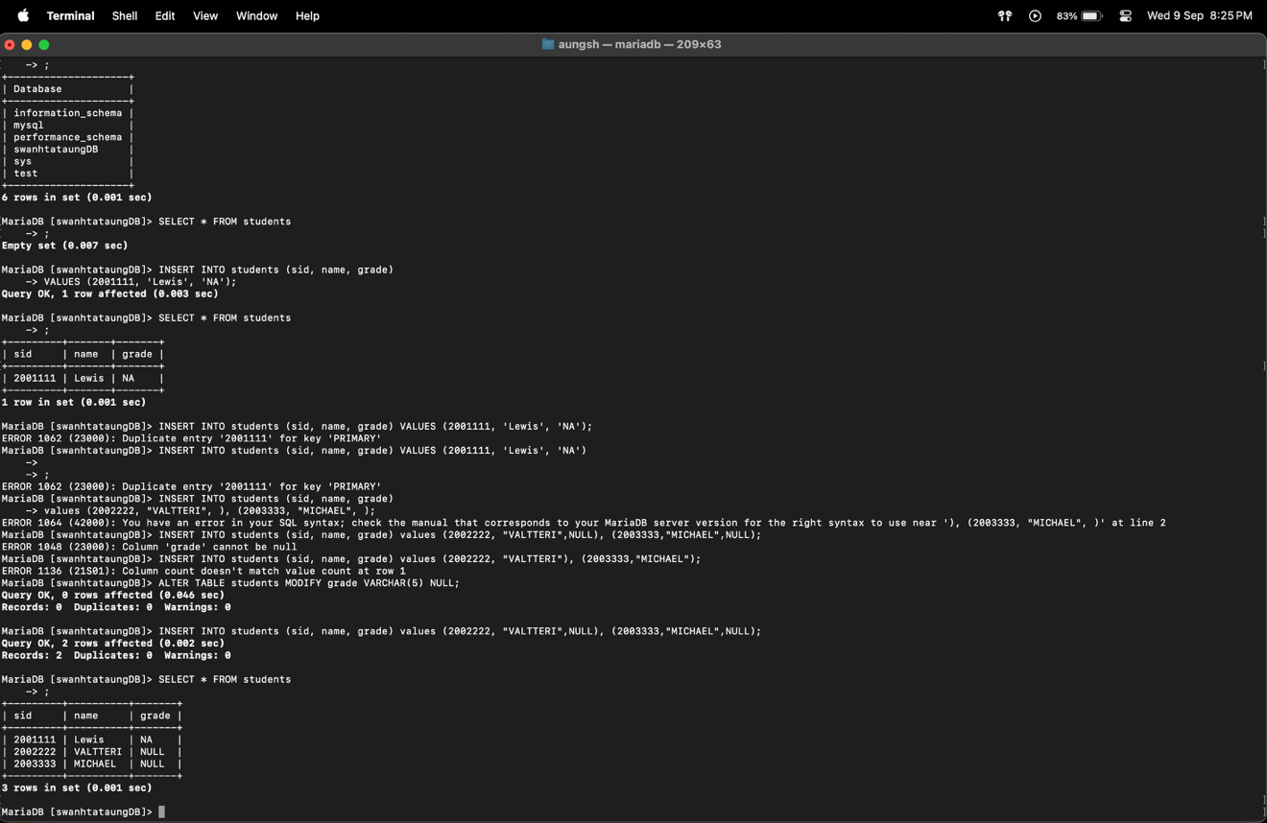

INSERT INTO students (sid, name, grade) VALUES (2001111, 'Lewis', 'NA');
SELECT * FROM students;
INSERT INTO students (sid, name, grade) values (2002222, "VALTTERI",NULL), (2003333,"MICHAEL",NULL);
SELECT * FROM students;

- Perform the 1st update operation by updating the grade of Michael’ to ‘A+’. Display all the rows in the latest table. Perform the 2nd update operation by updating the grade of Valtteri to ‘A-’. Display all the rows in the latest table.

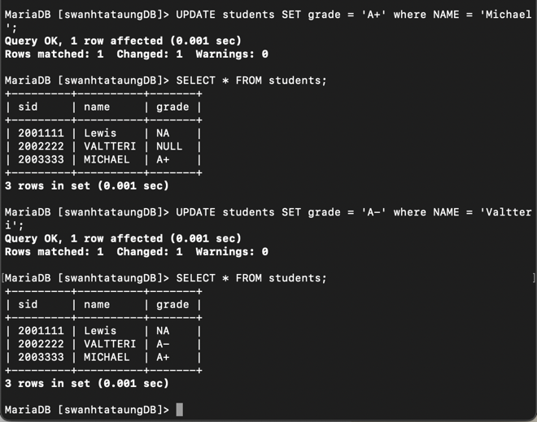

UPDATE students SET grade = 'A+' where NAME = 'Michael';
SELECT * FROM students;
UPDATE students SET grade = 'A-' where NAME = 'Valtteri';
SELECT * FROM students;

- Perform the 1st delete operation by deleting the student ‘Valtteri’. Display all the rows in the latest table. Perform the 2nd delete operation by deleting all the students in the table. Display all the rows in the latest table. Then, delete the database, and display all the databases as in the 2nd task.
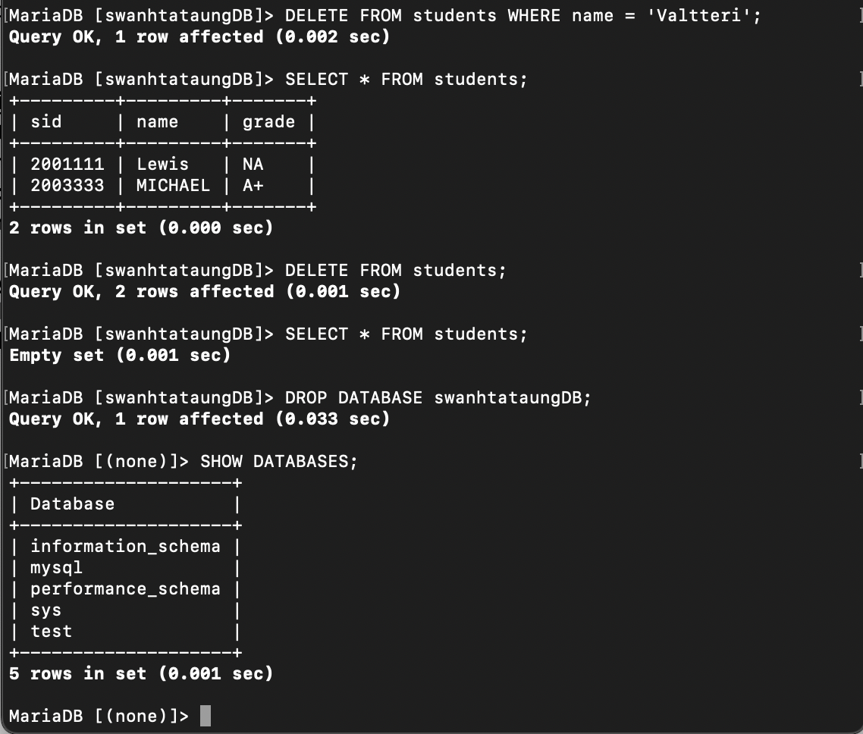

DELETE FROM students WHERE name = 'Valtteri';
SELECT * FROM students;
DELETE FROM students;
SELECT * FROM students;
DROP DATABASE swanhtataungDB;
SHOW DATABASES;

